**Progress report 13**

Tawab Karim

|  |  |
| --- | --- |
| Date | 03/12/2019 |
| Subject | Website |
| Project Term |  |

# Outcomes of the last meeting (26/11/2019)

* -

# Results during the last week(s)

* Had meeting with Tijmen, site will be updated the coming weeks and I can give feedback about it via him.
* Decided to switch to wordpress instead of HTML5 for the website, this while updating the website will be a lot easier. (talked with Jelmer about this choice)
* Finished drawings for Batch 5 and I’ve send these to Jan.
* 3D print made for Collimator alignment tool to verify functionality.

# Other business

* Jan/Nisse haven’t begun with batch 4 yet.
* Made a check out list for components that people take out of the lab, this way we know who has taken what and where it is.

# Plans for next week(s)

* This week I will ask Alex and Erica about the possibility to assemble the laserbox
* This week I will finalize the website in wordpress
* Next week I will start with the design of the new light sheet module

# Schedule current and next week

## This week

* Monday 0900-1500
* Wednesday 1100-1800

## Next Week

* Monday 0900-1500
* Wednesday 1100-1800

|  |  |  |  |  |
| --- | --- | --- | --- | --- |
| Project | Figure | Current Components | Needed Components | Earliest Due Date |
| DMD-Setup | LINK |  |  |  |
| TIRF-Setup | LINK | 1,2,3,4,6,7,8,10 | 5,9 | 30/09/2019 |
| LS-Module | LINK |  |  |  |

## 

|  |  |  |  |  |  |
| --- | --- | --- | --- | --- | --- |
| Figure no. | Component code | Component Name | Amount in Inventory | Amount in production | Production due date |
| 1 | CR001-A | Microscope Tower | 1 | 2 | 30/09/2019 |
| 2 | CR002-A | EM Plate | 1 | 2 | 30/09/2019 |
| 3 | CR003-A | FilterPlate | 1 | 2 | 30/09/2019 |
| 4 | CR004-A | CoverPlate V2 P1 | 1 | 2 | 30/09/2019 |
| 5 | CR005-A | CoverPlate V2 P2 | 0 | 3 | 30/09/2019 |
| 6 | CR006-A | BottomPlate | 1 | 2 | 30/09/2019 |
| 7 | CR007-A | Stage Mount | 3 | 0 | - |
| 8 | CR008-A | Stage Plate | 3 | 0 | - |
| 9 | CR009-A | Tube Lens Mount | 0 | 1 | 18/10/2019 |
| 10 | PP001-A | CameraMount | 2 | 0 | - |
| 11 | CR008-B | Stage Plate | 0 | 1 | 18/10/2019 |
| 12 | CR010-A | StageThorlabsAdapter-A | 0 | 1 | 18/10/2019 |
| 13 | CR011-A | StageThorlabsAdapter-B | 0 | 1 | 18/10/2019 |
| 14 | CR012-A | SpacerBlockStage | 0 | 1 | 18/10/2019 |
| 15 | CR013-A | FilterPlateStraight | 0 | 1 | 18/10/2019 |
| 16 | CR020-A | PanelLaserBox1 | 0 | 1 | 04/10/2019 |
| 17 | CR021-A | PanelLaserBox2 | 0 | 1 | 04/10/2019 |
| 18 | CR022-A | PanelLaserBox3 | 0 | 1 | 04/10/2019 |
| 19 | CR023-A | PanelLaserBox4 | 0 | 1 | 04/10/2019 |
| 20 | CR024-A | PanelLaserBox5 | 0 | 1 | 04/10/2019 |
| 21 | CR025-A | PanelLaserBox6 | 0 | 1 | 04/10/2019 |
| 22 | CR026-A | PanelLaserBox7 | 0 | 1 | 04/10/2019 |
| 23 | CR027-A | PanelLaserBox8 | 0 | 1 | 04/10/2019 |
| 24 | CR028-A | PanelLaserBox9 | 0 | 1 | 04/10/2019 |
| 25 | CR029-A | PanelLaserBox1D | 0 | 1 | 04/10/2019 |
| 26 | CR030-A | PanelLaserBox4D | 0 | 1 | 04/10/2019 |
| 27 | CR014-A | OuterBlock1 | 0 | 1 | 31/01/2020 |
| 28 | CR015-A | OuterBlock2 | 0 | 1 | 31/01/2020 |
| 29 | CR016-A | InnerBlock | 0 | 1 | 31/01/2020 |
| 30 | CR017-A | PolerazationConnector | 0 | 1 | 31/01/2020 |
| 31 | CR018-A | PolerazationSelector | 0 | 1 | 31/01/2020 |
| 32 | CR031-A | BackPlateMirror | 0 | 0 | - |
| 33 | CR032-A | MirrorRotMount | 0 | 0 | - |
| 34 | CR033-A | HoldPlate | 0 | 0 | - |
| 35 | CR034-A | Mounting | 0 | 0 | - |
| 36 | CR035-A | SidePlateConnector | 0 | 0 | - |
| 37 | CR036-A | SidePlateB | 0 | 0 | - |
| 38 | CR037-A | SidePlates | 0 | 0 | - |
| 39 | CR038-A | NemaMount | 0 | 0 | - |
| 40 | CR039-A | HaltePlatte | 0 | 2 | 31/01/2020 |
| 41 | CR040-A | Anschraubplatte | 0 | 2 | 31/01/2020 |
| 42 | CR041-A | Kugelhalter2 | 0 | 4 | 31/01/2020 |
| 43 | CR042-A | Kugelhalter | 0 | 2 | 31/01/2020 |
| 44 | CR043-A | Kugelhalter3 | 0 | 2 | 31/01/2020 |
| 45 | CR044-A | BasePlateStage | 0 | 1 | 20/12/2019 |
| 46 | CR045-A | MountingPlate | 0 | 2 | 20/12/2019 |
| 47 | CR046-A | StepConnectPlate | 0 | 1 | 20/12/2019 |
| 48 | CR047-A | BackPlateMirror | 0 | 1 | 20/12/2019 |
| 49 | CR048-A | HoldPlate | 0 | 1 | 20/12/2019 |
| 50 | CR049-A | MirrorRotMount | 0 | 1 | 20/12/2019 |
| 51 | CR050-A | Mounting | 0 | 1 | 20/12/2019 |
| 52 |  |  |  |  |  |
| 53 |  |  |  |  |  |
| 54 |  |  |  |  |  |
| 55 |  |  |  |  |  |
|  |  |  |  |  |  |
|  |  |  |  |  |  |
|  |  |  |  |  |  |
|  |  |  |  |  |  |
|  |  |  |  |  |  |
|  |  |  |  |  |  |
|  |  |  |  |  |  |
|  |  |  |  |  |  |
|  |  |  |  |  |  |
|  |  |  |  |  |  |
|  |  |  |  |  |  |

## Project figures

|  |
| --- |
| DMD-Setup |
|  |
| TIRF-Setup |
|  |
| LS-module |
| -image not yet made- |

## Component figures

|  |  |
| --- | --- |
| Figure 1 -- CR001-A | Figure 2 – CR002-A |
|  |  |
| Figure 3 – CR003-A | Figure 4 – CR004-A |
|  |  |
| Figure 5 – CR005-A | Figure 6 – CR006-A |
|  |  |
| Figure 7 – CR007-A | Figure 8 – CR008-A |
|  |  |
| Figure 9 – CR009-A | Figure 10 – PP001-A |
|  |  |
| Figure 13 – CR008-B | Figure 12 – CR010-A |
|  |  |
| Figure 13 – CR011-A | Figure 14 – CR012-A |
|  |  |
| Figure 15 – CR013-A | Figure 16 – CR020-A |
|  |  |
| Figure 17 – CR021-A | Figure 18 – CR022-A |
|  |  |
| Figure 19 – CR023-A | Figure 20 – CR024-A |
|  |  |
| Figure 21 – CR025-A | Figure 22 – CR026-A |
|  |  |
| Figure 23 – CR027-A | Figure 24 – CR028-A |
|  |  |
| Figure 25 – CR029-A | Figure 26 – CR030-A |
|  |  |
| Figure 27 – CR014-A | Figure 28 – CR015-A |
|  |  |
| Figure 29 – CR016-A | Figure 30 – CR017-A |
|  |  |
| Figure 31 – CR018-A | Figure 32 – CR031-A |
|  |  |
| Figure 33 – CR032-A | Figure 34 – CR033-A |
|  |  |
| Figure 35 – CR034-A | Figure 36 – CR035-A |
|  |  |
| Figure 37 – CR036-A | Figure 38 – CR037-A |
|  |  |
| Figure 39 – CR038-A | Figure 40 – CR039-A |
|  |  |
| Figure 41 – CR040-A | Figure 42 – CR041-A |
|  |  |
| Figure 43 – CR042-A | Figure 44 – CR043-A |
|  |  |
|  |  |
|  |  |
|  |  |
|  |  |
|  |  |
|  |  |

# Appendix

### 

### 

### 

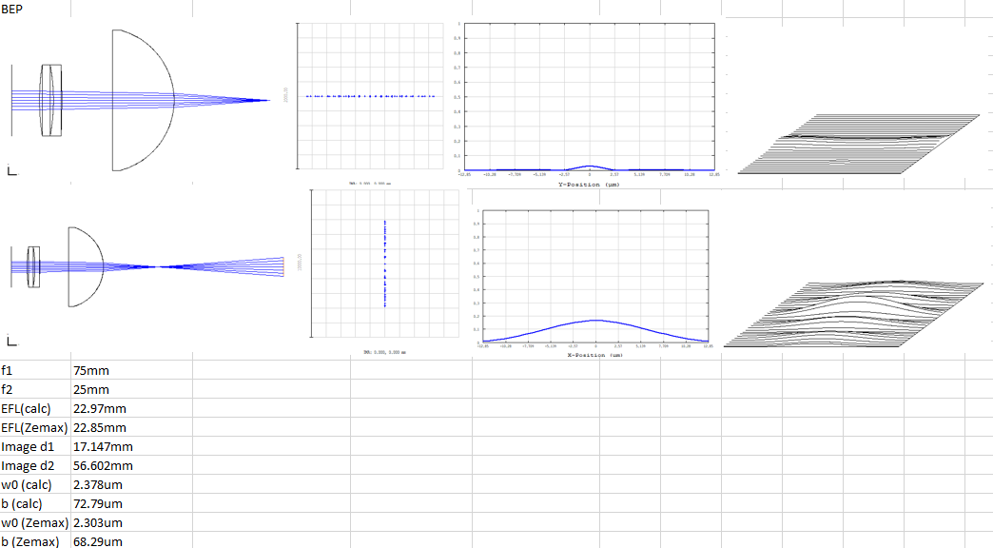

This is a summary of the simulations done with the components that the BEP group used. Looking at both focal distances of the light sheet. Hand calculations roughly match the simulations done in ZEMAX. The top row shows the first focal line of the light sheet and the second row shows the second focal line of the light sheet. From left to right, the setup, the dot diagram, the PSF cross section and the 3D PSF are shown.

This system has been compared to the inverted BEP setup, while the cilindrical lens is recommended to put the other way around. Results are shown below.

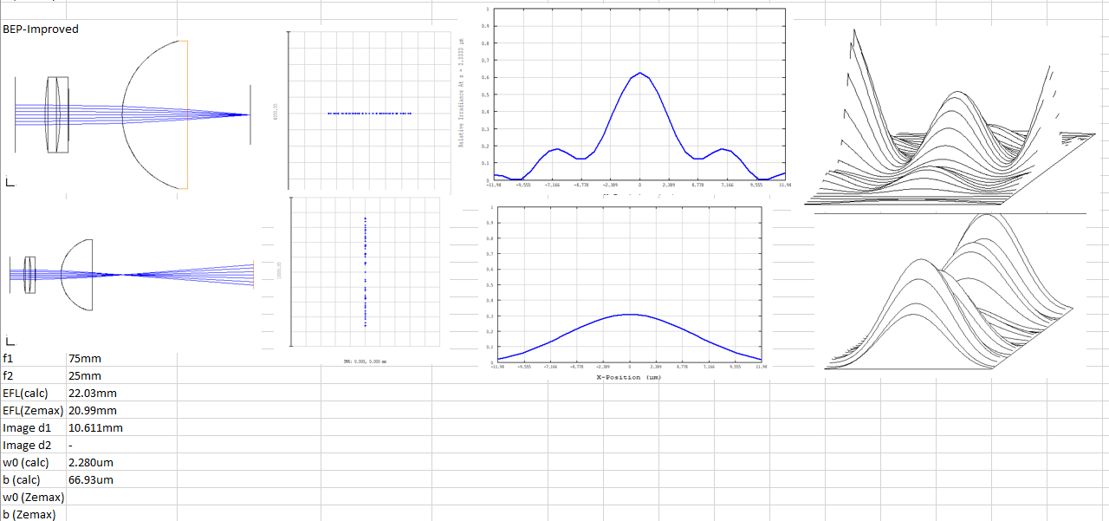

These two are compared to the AIM light sheet.

